***Get Fit Right Project Report***

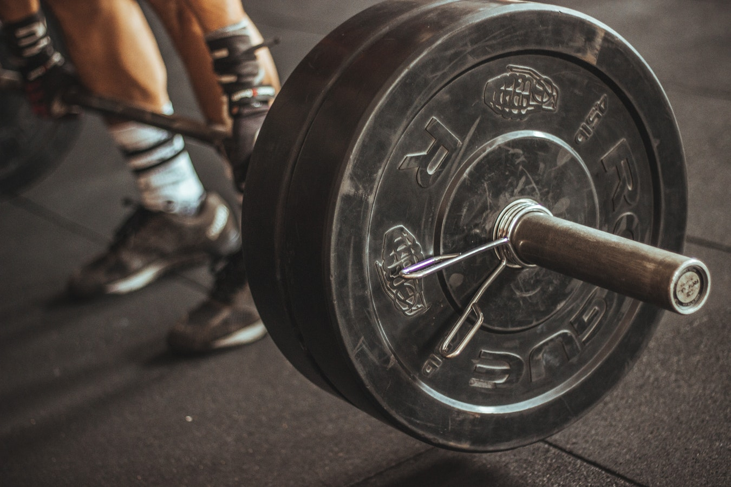

**Prepared by:**

**Group 12**

**Ahmed Khan, Edgar Martinez, Rameez Baig, Zakee Jabbar**

**CS 440**

**at the**

**University of Illinois Chicago**

**Fall 2018**

**Table of Contents**

List of Figures 7

List of Tables 8

I Project Description 9

1 Project Overview 9

2 The Purpose of the Project 9

2a The User Business or Background of the Project Effort 9

2b Goals of the Project 10

2c Measurement 10

3 The Scope of the Work 10

3a The Current Situation 10

3b The Context of the Work 11

3c Work Partitioning 11

3d Competing Products 12

4 The Scope of the Product 12

4a Scenario Diagram(s) 13

4b Product Scenario List 13

4c Individual Product Scenarios 13

5 Stakeholders 14

5a The Client 14

5b The Customer 14

5c Hands-On Users of the Product 14

5d Maintenance Users and Service Technicians 15

5e Other Stakeholders 15

5f User Participation 16

5g Priorities Assigned to Users 16

6 Mandated Constraints 16

6a Solution Constraints 16

6b Implementation Environment of the Current System 17

6c Partner or Collaborative Applications 17

6d Off-the-Shelf Software 18

6e Anticipated Workplace Environment 18

6f Schedule Constraints 19

6g Budget Constraints 19

7 Naming Conventions and Definitions 19

7a Definitions of Key Terms 19

7b UML and Other Notation Used in This Document 20

7c Data Dictionary for Any Included Models 20

8 Relevant Facts and Assumptions 20

8a Facts 20

8b Assumptions 21

II Requirements 21

9 Product Use Cases 21

9a Use Case Diagrams 21

9b Product Use Case List 22

9c Individual Product Use Cases 22

10 Functional Requirements 24

11 Data Requirements 25

12 Performance Requirements 26

12a Speed and Latency Requirements 26

12b Precision or Accuracy Requirements 27

12c Capacity Requirements 28

13 Dependability Requirements 29

13a Reliability Requirements 29

13b Availability Requirements 30

13c Robustness or Fault-Tolerance Requirements 31

13d Safety-Critical Requirements 32

14 Maintainability and Supportability Requirements 33

14a Maintenance Requirements 33

14b Supportability Requirements 34

14c Adaptability Requirements 35

14d Scalability or Extensibility Requirements 36

14e Longevity Requirements 36

15 Security Requirements 37

15a Access Requirements 37

15b Integrity Requirements 38

15c Privacy Requirements 39

15d Audit Requirements 40

15e Immunity Requirements 41

16 Usability and Humanity Requirements 41

16a Ease of Use Requirements 41

16b Personalization and Internationalization Requirements 43

16c Learning Requirements 44

16d Understandability and Politeness Requirements 45

16e Accessibility Requirements 46

16f User Documentation Requirements 47

16g Training Requirements 48

17 Look and Feel Requirements 49

17a Appearance Requirements 49

17b Style Requirements 50

18 Operational and Environmental Requirements 51

18a Expected Physical Environment 51

18b Requirements for Interfacing with Adjacent Systems 52

18c Productization Requirements 53

18d Release Requirements 54

19 Cultural and Political Requirements 55

19a Cultural Requirements 55

19b Political Requirements 56

20 Legal Requirements 57

20a Compliance Requirements 57

20b Standards Requirements 58

21 Requirements Acceptance Tests 59

21a Requirements – Test Correspondence Summary 59

21b Acceptance Test Descriptions 61

III Design 61

22 System Design 61

22a Design goals 61

23 Current Software Architecture 62

24 Proposed Software Architecture 62

24a Overview 62

24b Class Diagrams 62

24c Dynamic Model 62

24d Subsystem Decomposition 62

24e Hardware / software mapping 63

24f Data Dictionary 63

24g Persistent Data management 63

24h Access control and security 63

24i Global software control 63

24j Boundary conditions 63

25 Subsystem services 63

26 User Interface 63

27 Object Design 64

27a Object Design trade-offs 64

27b Interface Documentation guidelines 64

27c Packages 64

27d Class Interfaces 64

IV Project Issues 64

28 Open Issues 64

29 Off-the-Shelf Solutions 65

29a Ready-Made Products 65

29b Reusable Components 65

29c Products That Can Be Copied 66

30 New Problems 66

30a Effects on the Current Environment 67

30b Effects on the Installed Systems 67

30c Potential User Problems 68

30d Limitations in the Anticipated Implementation Environment That May Inhibit the New Product 68

30e Follow-Up Problems 69

31 Migration to the New Product 69

31a Requirements for Migration to the New Product 69

31b Data That Has to Be Modified or Translated for the New System 70

32 Risks 71

33 Costs 72

34 Waiting Room 73

35 Ideas for Solutions 73

36 Project Retrospective 74

V Glossary 75

VI References / Bibliography 75

VII Index 76

### ****List of Figures****

Figure 1 – Context of Work……………………………………………………………………...11

Figure 2 - Sample Use Case Diagram from Bruegge & DuToit ( modified ) 21

Figure 3 - Sample Use Case Diagram from Robertson and Robertson 22

### ****List of Tables****

*Table 2 - Requirements - Acceptance Tests Correspondence* 61

# Project Description

The *Get Fit Right* is a technology which utilizes motion capture to analyze the movements of a user while performing an exercise. *Get Fit Right* has two modes. A smart phone only mode which relies on the phones camera to track the user and give feedback. The second mode utilizes special body suits with built in sensors to connect to the phone and give more accurate data regarding the user. The second mode uses the data from the body suit and the smart phone to provide feedback. If a user is only lacking form, then the application will be able to advise them on what they’re doing wrong. If the error lies in a stiffness within the body, or lack of mobility, then the application will also be able to spot that and advise the user a plan to increase mobility in the problem area. The purpose of the device in general is to provide feedback to a user on the based on their movement to improve performance, increase mobility, and keep them safe during the duration of the exercise.

## Project Overview

The use of improper form during many of the more complex exercises – Deadlift, Squat, Snatch – can lead to injury. The goal of our simulator is taking a user through the exercise in a safe, comfortable environment where the risk of injury is as minimized as possible.

## The Purpose of the Project

This project is being done to combat a variety of problems, such as injury prevention, and to improve performance.

### The User Business or Background of the Project Effort

We are working with Nike, which is an athletic apparel and equipment business, in order to develop the Get Fit Right application. The application suits, which users will be able to wear, will be developed by them as well. The application was made with the intention of mitigating the amount of injury created in the gym. Nike sells products which are meant to improve an athlete’s performance. The creation of this application will allow Nike to sell shirts and pants that are meant to be captured by our motion capture software. The user will be able to utilize that product in the gym and receive accurate useful feedback on their weightlifting activity and improve because of it. Not only do we aim to battle injury and improve performance, but we wish to make an application readily to anyone who wishes to improve their technique. Therefore, we made the motion capture technology to work with just an ordinary smartphone. There is a plethora of terrible advice floating around in the wellness community, and most everyone knows of someone (or is that someone) who deals with gym anxiety because they don’t know if they’re doing something right. For this reason, we wanted to put that power in the hand of our users, and make precise, useful information readily available to anyone who wants to make a difference in their health.

### Goals of the Project

Our client, Nike, has just as much to benefit from their involvement in our technology as the users will. Our technology utilizes a smartphone for our motion capture technology, however, it also utilizes specialized shirts and pants that are created by our Client. The cost of a new workout outfit is far less than that of a personal trainer. The product is being made in order be the premiere choice for a user of any kind looking to improve their physique, or performance. We want to be able to give instant feedback to any user who utilizes our application. It should be intuitive, easy to use, and provide real usable advice.

### Measurement

Our app will have the ability for users to enter the height, weight, and test for flexibility. Upon the first use of our application, the Get Fit Right will administer a test in order to track where our users starting point is. Upon utilizing the application, one will be able to check in on their progress since every time they use it, data is collected. Improvements are measured and displayed in an easy depict visual representation. Once users see the results, we will be able to measure the success of the apps by the frequency that they use it, and by the reviews they leave on the IOS/Android respective app stores.

## The Scope of the Work

An application that allows people with any type of workout experience to correctly and safely workout by notifying them when performing an exercise incorrectly.

### The Current Situation

There are already lots of fitness apps out there for people to use to help them get fit and stay healthy. From running apps that track your time per mile to apps that track how much water you drink or food you eat. The current issue with this apps is that they don’t alert the user when they are working out incorrectly, leading to unsafe workouts, resulting in unwarranted injuries when working out.

Our solution consists of an application that uses a client’s camera to track posture when working out and alerting them when their posture is incorrect thus avoiding unsafe workouts. By improving user experience when working out it allows our clients to work out without worrying about technique and focus on what really matters about working out, getting healthy. 3b

### The Context of the Work

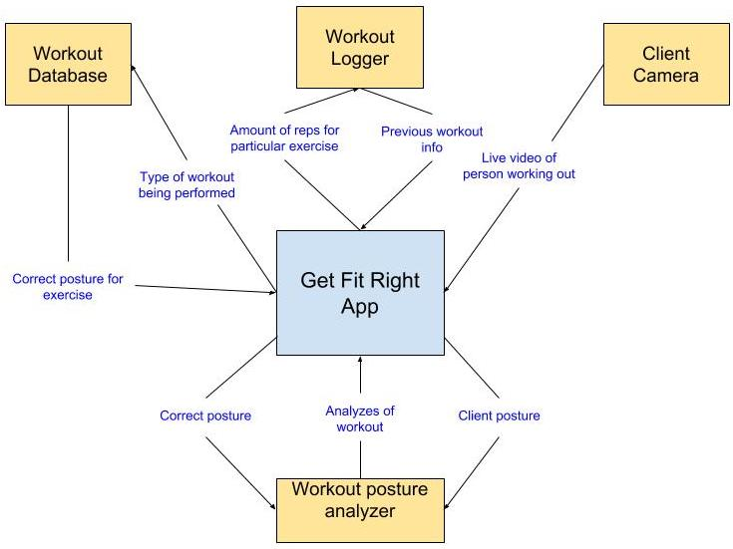

Figure - Context of Work

### Work Partitioning

|  |  |  |
| --- | --- | --- |
| **Event Name** | **Input and Output** | **Summary** |
| Workout database determining type of workout | Type of workout (out) | Sends the type of workout so to be able to receive the posture of the exercise. |
| Workout database knowing the workout | Posture Info (in) | Sends the information for the type of posture needed for that exercise. |
| Client camera video | Live video of workout (in) | Video received from camera that will be used to determine if posture is correct. |
| Posture video analyzer | Posture info and live video of workout (out) | Receives both the correct posture info and the live video of the workout that will be compared to inform the user if his/her posture is correct. |
| Posture video analyzer result | Update of workout (in) | Update to the app that will notify the user if posture is correct in live time based on results from the analyzer. |
| Exercise logger | Exercise Info (out) | Sends the amount of exercise and other data gathered the user did to cloud storage system so that user can access data from any of his/her devices. |
| Exercise history | Exercise Info (In) | Retrieves the previous workout sessions info so that user sees progression over time. |

### Competing Products

There are currently many applications available to help people get into shape and teach them new exercises, but none of them notify the user if they are correctly performing their workout. The current selection of applications offer the user no notifications in real time to inform them if they are correctly performing the exercise, thus putting people in danger of needless injuries. Most of these applications just offer videos or images of the workout to the user, completely ignoring people’s safety when performing new exercises by offering live feedback to the user based on their posture.

## The Scope of the Product

The main idea behind this product is to be able to tell a user if the workout that he or she is performing is being done correctly. This is done using a person’s smartphone and capturing video of them working out and instantly notifying them if they are doing their workout using good or bad technique. Also included in the application will be a workout logger that helps the user lookup previous workout and what type of exercises were performed that day and other valuable information like the amount of repetitions and if the workout was done using the correct posture and technique.

### Scenario Diagram(s)

A close up of text on a white background

Description generated with high confidence

Figure 2 - Project Scenario

### Product Scenario List

1. Initial Startup
2. Starting a workout
   1. Using Smartphone camera
   2. Live feedback of workout
3. Looking at previous workouts

### Individual Product Scenarios

1. **Initial Startup:** John decides to run Get Fit Right app on his smartphone. He has received as a gift for his birthday a set of weights, problem is that he doesn’t know if he is correctly performing his workouts. So when he opens the application for the first time John is asked to input his current vitals and measurements. After he enters his information he is given the option to start a workout or to look at previous workouts.
2. **Starting a workout:** John decides to start a workout so on his smartphone he selects this option. By doing so John will receive notifications on his phones screen in real time as he works out displaying whether he is correctly performing the workout based on his posture and comparing it to the correct posture. John also places his phone in at an angle that records his workout for the analytical part.
   1. **Using Camera:** By using his camera John is recording his workout and its being analyzed in real time using machine learning on the local device and it will notify him if the workout is done correctly.
   2. **Receiving Feedback:** John has completed a set of repetitions for a barbell squat. He looks at his phone and proceeds to hit the “DONE” button. The app then takes a second to process all of the data, and then displays a list of analyses of John’s set. After John sees the analyses, the app then creates recommendations based on John’s performance. The app recognizes that John’s form quickly turned bad after rep 4 out of 8, therefore the app recommends John to use a lighter weight for the next set in order to avoid injury. John presses “CONTINUE” on the app and moves on to the next set.
3. **Looking at previous workouts:** John doesn’t feel like working out today, but instead wants to reminisce about last Tuesday’s workout. He wants to see how many squats he performed. Along with how many squats he did John can also see how much weight he squatted that day along with data that shows if John performed his workout correctly based on the analysis that was done that day.
   1. **Retrieving Data:** John decides to use his computer one day because his phone broke to view last weeks workout data and is able to because his data was sent to the cloud so that he can access it from any of his devices and doesn’t have to worry about it getting lost which makes John very happy since he can show his workouts to other people from anywhere in the world on any device connected to the internet.

## Stakeholders

### The Client

The client is Nike Incorporated, a multinational corporation that is a leader in the design, development, and manufacturing of footwear, apparel, equipment, accessories, and services.

### The Customer

The intended purchasers of this product are professional sports teams, gym owners, and personal trainers. Any individual who helps others improve their fitness is a potential customer.

### Hands-On Users of the Product

Professional Athletes: Athletes will use this app to improve their overall performance. From tracking a throw from the quarterback to the swing of a power hitter, the app will provide feedback on the essential skillsets of an athlete in any sport. Professional athletes are already at a master level in their fields, but this will allow them to further practice their “textbook” skills, so that they can make “textbook” plays. Athletes already use high tech technology for their training, and this will be a perfect add-on to their training options. Since their technological experience is already at a master level, using any kind of new technology will be a breeze. Apart from improving their in-game skills, athletes can also use this to assist with their weight training and agility workouts.

Gym Goers: There are varying levels of gym goers. There are fitness buffs, who walk around the gym with their duffel bags and their protein shakes to take before, during, and after their workouts. Their knowledge of fitness and exercise ranges from a journeyman to a master level. These types of people are looking for that something extra to make them lose that one percent of body fat or make them hit their next PR (persona record). The other subgroup are the regular gym members. Their knowledge of fitness and exercise ranges from novice to journeyman. Gym goers would use this app to ensure they are performing the exercises with proper form and repetitions. The technological experience of this group varies from novice to master. The older gym goers tend to be novices, while the younger gym goers tend to be masters.

### Maintenance Users and Service Technicians

There would be a team of software developers that maintain and update the app, add new features, and resolve bugs that are discovered by the users. Another team would be required to service the hardware aspects of this product. The hardware team would make changes and create new designs of the clothing pieces, as well as troubleshoot any issues that arise in either connectivity or usability of the product. Ideally, there would be an employee at every Nike store who was trained to help with issues regarding this product.

### Other Stakeholders

Patent lawyers: Lawyers will ensure that others do not steal our ideas and products. They will follow all rules and regulations and prevent the company from intellectual property infringement.

Fitness Professionals: Provide data for our exercise database. Give us baselines on how to perform a certain exercise. These can include coaches, trainers, doctors, and scientists.

Google Fit, MyFitnessPal: Current popular fitness apps that would need to add new features to keep up with *Get Fit Right*. These apps only cover limited amount of our features and tend to serve the same audience.

Adidas, Under Armour: These companies would need to create a similar app to keep up with Nike which is one of their main competitors. Adidas recently lost its NBA contracts to Nike. To avoid further losses in business these companies would need to invent new products.

### User Participation

Professional Athletes: Athletes can suggest different actions and maneuvers that they would like special training on. Preferably specific skills that can’t be assessed manually.

Gym Goers: Gym goers can test out the preliminary versions of the UI to give feedback and suggestions to the developers to create a better UI for when the product launches.

### Priorities Assigned to Users*.*

Key Users: Gym Goers (80% of users) – Gym goers will be the primary users of this app. These are the users that need the most feedback on their exercises as a lot of these users are in the novice to journeyman level of expertise on the topic.

Secondary Users: Professional Athletes (20% of users) – Athletes don’t require the same level of assistance and feedback as gym goers do. Their use for this app is more of an additional tool to improve and track their performance. This app won’t be their primary tool for improvement, so it is better to spend more time developing towards the gym goers.

## Mandated Constraints

This section describes constraints on the design of the product. These constraints have been mandated by the client at the beginning of the project before the full set of requirements had been determined and are set in stone. Any other solution that does not follow these constraints are unacceptable.

### Solution Constraints

Description: The software of the product shall be available on the Apple App Store and the Google Play Store.

Rationale: The client wants as many customers as possible to be able to use the base version of the application without having to purchase additional hardware.

Fit Criterion: The product shall be compliant with Apple and Google guidelines and requirements in order to be available on each respective app store.

Description: The software of the product shall be downloadable on a minimum of 85% devices for each respective app store.

Rationale: The client does not want to limit its user base simply on what version of iOS/Android OS the customer’s device is running.

Fit Criterion: Percentage distribution of devices and operating system versions can be found on Google’s and Apple’s distribution dashboards:

Apple: <https://developer.apple.com/support/app-store/>

Google: <https://developer.android.com/about/dashboards/>

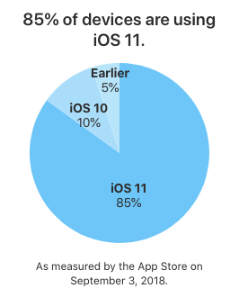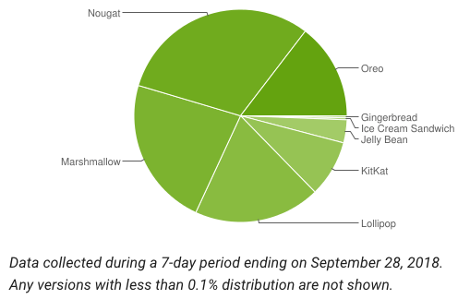

Description: The wearable technology available in the advanced system must be compliant with United States clothing guidelines and regulations.

Rationale: The advanced system of the product will only be sold within the United States; therefore, it must follow guidelines set by the government.

Fit Criterion: Must follow all regulatory guidelines through the Federal Trade Commission under the Textile and Wool Acts.

### Implementation Environment of the Current System

The iOS version of the application must be developed using Swift and not Objective-C.

Swift is given preference over Objective-C due to the fact that the latter is an outdated technology that is more is more prone to error than the former.

The Android version of the application must be developed using Java and not Kotlin.

Java is given preference over Kotlin due to the fact that the former is a very well-known language throughout the world as compared to the latter. According to the client, Kotlin is too young of a language to be used in an enterprise application.

### Partner or Collaborative Applications

External applications with which this product must be compatible with include the Apple Health app and the Google Fit app.

These are the applications that are maintained by the owners of the operating system the product will be supported on, therefore there is a greater chance that the user utilizes these applications.

The product must be able to read in user data from these apps, but also be able to update the data by writing to these apps. This has been mandated to allow the user to easily monitor and track his/her progress in parallel with any other third-party application that is also compatible with Apple Health and Google Fit.

### Off-the-Shelf Software

The product must implement Adobe Acrobat Reader.

This is required to print an editable PDF of the user’s data and progress through the most commonly accepted means of distribution.

Adobe Acrobat Reader is a free software tool used to read PDF documents. Files are handled differently depending on the operating system, and the client does not want to alienate a certain population of customers simply on the operating system he/she prefers. This also allows the customer to share necessary data easily with his/her trainer or primary care physician without worry since PDFs and Adobe Acrobat Reader are not reliant on a license, like Microsoft Word and Excel are.

### Anticipated Workplace Environment

The general description of the workplace is an open floor environment that allows the user to easily and freely perform the desired exercise within adequate range of the sensory camera. Environments include, but are not limited to recreational and professional gyms, physical therapy offices, and any environment that is deemed safe for the pursuant activity.

The workplace is noisy; therefore, notifications must be visible and audible at a high enough frequency to be seen and heard.

The workplace is large; therefore, the application must be able to accurately measure distance from the user.

The workplace is potentially dangerous; therefore, the application must not distract the user from being aware of his/her surroundings.

The workplace is fast paced; therefore, the application must be able to track and distinguish the user and his/her equipment from others.

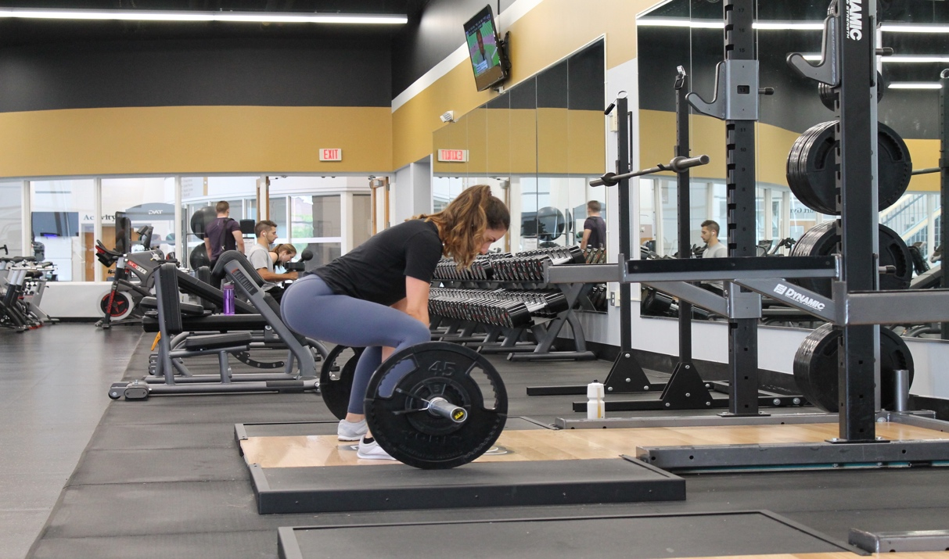

### Schedule Constraints

A working demo of the application must be presented to the client every 3 months to show what progress has been made, and whether certain functionality must take precedence over others.

The final release of the applications on the App/Play Stores and the release of the apparel has been planned for the end of 2020 to meet the needs of the client.

Once the apps have been released, frequent updates to the applications must take place to fix bugs and optimize the applications on future operating system upgrades.

### Budget Constraints

The client has proposed $100,000 to successfully create the applications for iOS and Android, and another $100,000 to successfully create the apparel that will be used for the advanced system of the application.

Based off estimates from <http://howmuchtomakeanapp.com/> this budget is very realistic to build this product.

Factors that have been considered for the budget constraints include developer and designer salaries, infrastructure costs for the machine learning database, and warehouse rent and employee maintenance for the apparel.

## Naming Conventions and Definitions

### Definitions of Key Terms

Below is the list of some of the most important words which include acronyms and abbreviations. See the glossary at the end of the document for a complete list.

“Textbook” – When something is executed perfectly it can be described using this word.

PR – Personal records. Common uses is when an individual reaches a new weight on a lift or a runner completes a race beating their own personal record.

Other important keywords will be added as necessary.

### UML and Other Notation Used in This Document

This document generally follows the Version 2.0 OMG UML standard, as described by Fowler in [4]. Any exceptions are noted where used.

### Data Dictionary for Any Included Models

All data would be stored in tables in the back-end database.

Table 1: User Profile Data

Fields: Name, Age, Sex, Date of Birth, Weight, Height. Activity Level (On a scale of 1-4 how active is a user)

Table 2: User History Data

Fields: Activity, Duration, Reps (If applicable), Sets (If applicable), Accuracy (Percentage of how accurate the activity of performed), Suggestions (Future actions suggested to the user)

Table 3: Exercise Data

Fields: Name (Name of exercise), Category (Under what general category does this exercise lie), User type (Which user is this meant for), Suggestions (List of suggestions for this exercise), Accuracy Info (Evaluation metrics for this exercise)

Other tables will be added as necessary.

## Relevant Facts and Assumptions

### Facts

iOS code written in Swift must be in Xcode and Xcode is only available on Mac OS.

Android code written in Java must be in Android Studio and Android Studio is available on all platforms.

Android applications use Material Design, while iOS applications use Human Interface Design.

Every smart phone camera has a different number of front-facing megapixels. smart

Men and women sizes are labeled differently.

### Assumptions

Cotton is the best well-rounded material to use when making clothes.

The user already owns an iOS or an Android OS device.

Certain open-source machine learning APIs are already available to integrate and expand upon within this application

User data is readily available through the Apple Health app or the Google Fit app.

Monetary resource disbursements are released at the end of every demo update with the client.

The product cannot move on to the next stage after a demo update if functionality or aesthetic implementation does not please the client.

# Requirements

## Product Use Cases

### Use Case Diagrams

### Product Use Case List

### Individual Product Use Cases

## Functional Requirements

**ID# - Name**

**Description:** Your description here . . .

**Rationale:** Your rationale here . . .

**Fit Criterion:** Your fit criteria here . . .

**Acceptance Tests:** List ID# and/or names here . . .

## Data Requirements

**ID# - Name**

**Description:** Your description here . . .

**Rationale:** Your rationale here . . .

**Fit Criterion:** Your fit criteria here . . .

**Acceptance Tests:** List ID# and/or names here . . .

## Performance Requirements

### Speed and Latency Requirements

**ID# - Name**

**Description:** Your description here . . .

**Rationale:** Your rationale here . . .

**Fit Criterion:** Your fit criteria here . . .

**Acceptance Tests:** List ID# and/or names here . . .

### Precision or Accuracy Requirements

**ID# - Name**

**Description:** Your description here . . .

**Rationale:** Your rationale here . . .

**Fit Criterion:** Your fit criteria here . . .

**Acceptance Tests:** List ID# and/or names here . . .

### Capacity Requirements

**ID# - Name**

**Description:** Your description here . . .

**Rationale:** Your rationale here . . .

**Fit Criterion:** Your fit criteria here . . .

**Acceptance Tests:** List ID# and/or names here . . .

## Dependability Requirements

### Reliability Requirements

**ID# - Name**

**Description:** Your description here . . .

**Rationale:** Your rationale here . . .

**Fit Criterion:** Your fit criteria here . . .

**Acceptance Tests:** List ID# and/or names here . . .

### Availability Requirements

**ID# - Name**

**Description:** Your description here . . .

**Rationale:** Your rationale here . . .

**Fit Criterion:** Your fit criteria here . . .

**Acceptance Tests:** List ID# and/or names here . . .

### Robustness or Fault-Tolerance Requirements

**ID# - Name**

**Description:** Your description here . . .

**Rationale:** Your rationale here . . .

**Fit Criterion:** Your fit criteria here . . .

**Acceptance Tests:** List ID# and/or names here . . .

### Safety-Critical Requirements

**ID# - Name**

**Description:** Your description here . . .

**Rationale:** Your rationale here . . .

**Fit Criterion:** Your fit criteria here . . .

**Acceptance Tests:** List ID# and/or names here . . .

## Maintainability and Supportability Requirements

### Maintenance Requirements

**ID# - Name**

**Description:** Your description here . . .

**Rationale:** Your rationale here . . .

**Fit Criterion:** Your fit criteria here . . .

**Acceptance Tests:** List ID# and/or names here . . .

### Supportability Requirements

**ID# - Name**

**Description:** Your description here . . .

**Rationale:** Your rationale here . . .

**Fit Criterion:** Your fit criteria here . . .

**Acceptance Tests:** List ID# and/or names here . . .

### Adaptability Requirements

**ID# - Name**

**Description:** Your description here . . .

**Rationale:** Your rationale here . . .

**Fit Criterion:** Your fit criteria here . . .

**Acceptance Tests:** List ID# and/or names here . . .

### Scalability or Extensibility Requirements

**ID# - Name**

**Description:** Your description here . . .

**Rationale:** Your rationale here . . .

**Fit Criterion:** Your fit criteria here . . .

**Acceptance Tests:** List ID# and/or names here . . .

### Longevity Requirements

**ID# - Name**

**Description:** Your description here . . .

**Rationale:** Your rationale here . . .

**Fit Criterion:** Your fit criteria here . . .

**Acceptance Tests:** List ID# and/or names here . . .

## Security Requirements

### Access Requirements

**ID# - Name**

**Description:** Your description here . . .

**Rationale:** Your rationale here . . .

**Fit Criterion:** Your fit criteria here . . .

**Acceptance Tests:** List ID# and/or names here . . .

### Integrity Requirements

**ID# - Name**

**Description:** Your description here . . .

**Rationale:** Your rationale here . . .

**Fit Criterion:** Your fit criteria here . . .

**Acceptance Tests:** List ID# and/or names here . . .

### Privacy Requirements

**ID# - Name**

**Description:** Your description here . . .

**Rationale:** Your rationale here . . .

**Fit Criterion:** Your fit criteria here . . .

**Acceptance Tests:** List ID# and/or names here . . .

### Audit Requirements

**ID# - Name**

**Description:** Your description here . . .

**Rationale:** Your rationale here . . .

**Fit Criterion:** Your fit criteria here . . .

**Acceptance Tests:** List ID# and/or names here . . .

### Immunity Requirements

**ID# - Name**

**Description:** Your description here . . .

**Rationale:** Your rationale here . . .

**Fit Criterion:** Your fit criteria here . . .

**Acceptance Tests:** List ID# and/or names here . . .

## Usability and Humanity Requirements

### Ease of Use Requirements

**ID# - Name**

**Description:** Your description here . . .

**Rationale:** Your rationale here . . .

**Fit Criterion:** Your fit criteria here . . .

**Acceptance Tests:** List ID# and/or names here . . .

### Personalization and Internationalization Requirements*.*

**ID# - Name**

**Description:** Your description here . . .

**Rationale:** Your rationale here . . .

**Fit Criterion:** Your fit criteria here . . .

**Acceptance Tests:** List ID# and/or names here . . .

### Learning Requirements

**ID# - Name**

**Description:** Your description here . . .

**Rationale:** Your rationale here . . .

**Fit Criterion:** Your fit criteria here . . .

**Acceptance Tests:** List ID# and/or names here . . .

### Understandability and Politeness Requirements

**ID# - Name**

**Description:** Your description here . . .

**Rationale:** Your rationale here . . .

**Fit Criterion:** Your fit criteria here . . .

**Acceptance Tests:** List ID# and/or names here . . .

### Accessibility Requirements

**ID# - Name**

**Description:** Your description here . . .

**Rationale:** Your rationale here . . .

**Fit Criterion:** Your fit criteria here . . .

**Acceptance Tests:** List ID# and/or names here . . .

### User Documentation Requirements

**ID# - Name**

**Description:** Your description here . . .

**Rationale:** Your rationale here . . .

**Fit Criterion:** Your fit criteria here . . .

**Acceptance Tests:** List ID# and/or names here . . .

### Training Requirements

**ID# - Name**

**Description:** Your description here . . .

**Rationale:** Your rationale here . . .

**Fit Criterion:** Your fit criteria here . . .

**Acceptance Tests:** List ID# and/or names here . . .

## Look and Feel Requirements

### Appearance Requirements

**ID# - Name**

**Description:** Your description here . . .

**Rationale:** Your rationale here . . .

**Fit Criterion:** Your fit criteria here . . .

**Acceptance Tests:** List ID# and/or names here . . .

### Style Requirements

**ID# - Name**

**Description:** Your description here . . .

**Rationale:** Your rationale here . . .

**Fit Criterion:** Your fit criteria here . . .

**Acceptance Tests:** List ID# and/or names here . . .

## Operational and Environmental Requirements

### Expected Physical Environment

**ID# - Name**

**Description:** Your description here . . .

**Rationale:** Your rationale here . . .

**Fit Criterion:** Your fit criteria here . . .

**Acceptance Tests:** List ID# and/or names here . . .

### Requirements for Interfacing with Adjacent Systems

**ID# - Name**

**Description:** Your description here . . .

**Rationale:** Your rationale here . . .

**Fit Criterion:** Your fit criteria here . . .

**Acceptance Tests:** List ID# and/or names here . . .

### Productization Requirements

**ID# - Name**

**Description:** Your description here . . .

**Rationale:** Your rationale here . . .

**Fit Criterion:** Your fit criteria here . . .

**Acceptance Tests:** List ID# and/or names here . . .

### Release Requirements

**ID# - Name**

**Description:** Your description here . . .

**Rationale:** Your rationale here . . .

**Fit Criterion:** Your fit criteria here . . .

**Acceptance Tests:** List ID# and/or names here . . .

## Cultural and Political Requirements

### Cultural Requirements

**ID# - Name**

**Description:** Your description here . . .

**Rationale:** Your rationale here . . .

**Fit Criterion:** Your fit criteria here . . .

**Acceptance Tests:** List ID# and/or names here . . .

### Political Requirements

**ID# - Name**

**Description:** Your description here . . .

**Rationale:** Your rationale here . . .

**Fit Criterion:** Your fit criteria here . . .

**Acceptance Tests:** List ID# and/or names here . . .

## Legal Requirements

### Compliance Requirements

**ID# - Name**

**Description:** Your description here . . .

**Rationale:** Your rationale here . . .

**Fit Criterion:** Your fit criteria here . . .

**Acceptance Tests:** List ID# and/or names here . . .

### Standards Requirements

**ID# - Name**

**Description:** Your description here . . .

**Rationale:** Your rationale here . . .

**Fit Criterion:** Your fit criteria here . . .

**Acceptance Tests:** List ID# and/or names here . . .

## Requirements Acceptance Tests

### Requirements – Test Correspondence Summary

### Acceptance Test Descriptions*.*

**ID # - Name**

**Description:** Your description here . . .

# Design

## System Design

### Design goals

Your text goes here . . .

## Current Software Architecture

Your text goes here . . .

## Proposed Software Architecture

### Overview

Your text goes here . . .

### Class Diagrams

Your text goes here . . .

### Dynamic Model

Your text goes here . . .

### Subsystem Decomposition

Your text goes here . . .

### Hardware / software mapping

Your text goes here . . .

### Data Dictionary

Your text goes here . . .

### Persistent Data management

Your text goes here . . .

### Access control and security

Your text goes here . . .

### Global software control

Your text goes here . . .

### Boundary conditions

Your text goes here . . .

## Subsystem services

Your text goes here . . .

## User Interface

Your text goes here . . .

## Object Design

### Object Design trade-offs

Your text goes here . . .

### Interface Documentation guidelines

Your text goes here . . .

### Packages

Your text goes here . . .

### Class Interfaces

Your text goes here . . .

# Project Issues

## Open Issues

Your text goes here . . .

## Off-the-Shelf Solutions

Your text goes here . . .

### Ready-Made Products

Your text goes here . . .

### Reusable Components

Your text goes here . . .

### Products That Can Be Copied

Your text goes here . . .

## New Problems

### Effects on the Current Environment

Your text goes here . . .

### Effects on the Installed Systems

Your text goes here . . .

### Potential User Problems

Your text goes here . . .

### Limitations in the Anticipated Implementation Environment That May Inhibit the New Product

Your text goes here . . .

### Follow-Up Problems

Your text goes here . . .

## Migration to the New Product

### Requirements for Migration to the New Product

Your text goes here . . .

### Data That Has to Be Modified or Translated for the New System

Your text goes here . . .

## Risks

Your text goes here . . .

## Costs

Your text goes here . . .

## Waiting Room

Your text goes here . . .

## Ideas for Solutions

Your text goes here . . .

## Project Retrospective

Your text goes here . . .

# Glossary

Your text goes here . . .

# References / Bibliography

|  |  |
| --- | --- |
| [1] | Robertson and Robertson, Mastering the Requirements Process. |
| [2] | A. Silberschatz, P. B. Galvin and G. Gagne, Operating System Concepts, Ninth ed., Wiley, 2013. |
| [3] | J. Bell, "Underwater Archaeological Survey Report Template: A Sample Document for Generating Consistent Professional Reports," Underwater Archaeological Society of Chicago, Chicago, 2012. |
| [4] | M. Fowler, UML Distilled, Third Edition, Boston: Pearson Education, 2004. |

# Index

Design 61, 63

Requirements 35, 51, 58

Test 64, 65